# Pryce 5-pc. Dining Set

Description $799.95

With its bold, clean design, beautiful wood grain and upholstered seating, the Pryce 5-piece dining set creates an undeniably elegant look. One of the first things you're sure to notice about this group is the sunburst veneer pattern in the round dining table. Button tufting in the light gray upholstery of the side chairs, gold-finished hardware and a brown cherry finish add subtly chic detail.

Product Details

* Color Light Gray / Medium Cherry
* Style Mid-Century Modern
* Finis Cherry
* Dining Height Standard
* Pieces in Se t5
* Fabric Fabric
* Table Base Type Pedestal
* Table Shape Round
* Seating Type Dining
* Weigh 0 lbs
* Seat Depth 17.00
* Seat Height 19.50
* Care Lightly brush or vacuum frequently to remove dust and grime. Spot clean with water- or solvent-based cleaners. Pre-test cleaning methods on a hidden surface. A professional cleaning service is recommended for an overall soiled condition.
* 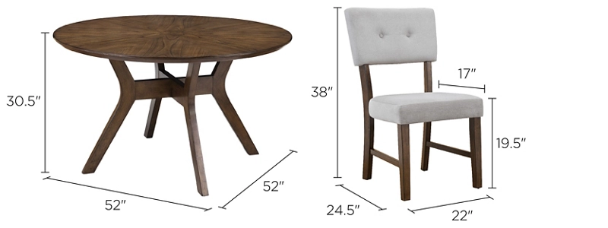Vendor Bellanest